Exhibitor Manual System – Observation Report by Date: 27 June 2018;
1) User cannot be select before back date. However, sale stall booking can be recorded on current period of year.
2)if any event/exhibition name is already existing system should be alert message of duplication.
3) system should be automatically close/restricted to record all transaction by created no. Of days (Date & time) periods.
4) Built-in currency exchange calculation (USD$ to Pkr) option available on sales & booking form. (remove price type from exhibition create form)
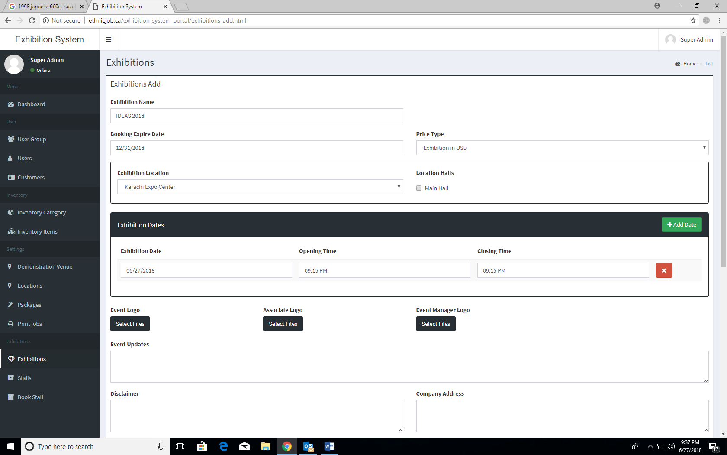
5) what is (main hall location)? on exhibition create form

6) System should be auto take the first added exhibition day when add next day.
7) All dropdown list should have Add New button with Live Add new List option or Category if any option list selection category or option is not available in dropdown selection (Important)
8) System should be recorded Event Organization Contact or information during exhibition create form as dropdown list
9) Remove Event Update Entry option from Create Exhibition and Add New System Menu with all kind of Notification, News Alert and Updates regarding Events. (also, we already discussed past meeting that we required separate modules for User Messages system and Notification such as Client-Side portal on header event updates notification, by Email and SMS etc.
10)Dashboard content? (all kind of related event notification should be available on separate module of User Messages menu.
11) Remove Wall Ads Area and discussed next meeting (Important) Online Web Client Panel Branding
12) Application Sidebar Menu should be collapsible navigation feature to minimized and extended by user click – (Important)
13) All system form field related error should be visible with bootstrap Popup model box and also highlighted Error Form content.
14) All designed form mandatory (Required) field should have (*) sign and color Red.
15) Add New Event Form selected, or Added Date should not accept same date of event with time. (Important Error)
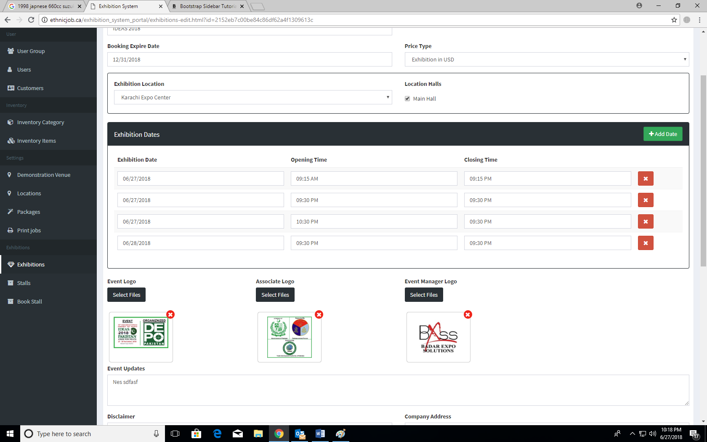

16) Remove Hall Create option from Location because location mean venue information and it will because change according Exhibition Setup different.
17) Required separate Hall Creation menu with relation of created Exhibition. (Important)
18) Required Hall Add by range numbers of hall and also signal entry by hall name (don’t require any Hall other information like Covering Area.
19) Required Hall Titling (Menu name with Hall Pavilion) discussed next meeting.
20) System table database should be Indexing and Key and Foreign key DBMS concept that user cannot delete if any parent and child database are created like, Exhibition Hall Shall. (System Error)
21) in case if any parent records have any child foreign key records exist in related database then user only can de-active or reactive. (but system shall not allow to delete directly parent database from and records.
22) System must have Active or De-active Option for safe records and reports by Post or Un-post concept.

Need to Discuss Next Meeting (at Soluit Office, 28-6-2018) 11:30 AM
Meeting Conductors:
Junaid Ali (Facilitation Dept.)
Zubair Qadri (IT Dept.)
*Action Require deadline;
- Completed First Setup to Create Exhibition
  - Create Location and Venue
  - Create Exhibition by Venue
  - Create Hall by Exhibition
  - Create Shall by Hall & Exhibition

